Mama Vesuvio’s East
6361 West College Drive
Palos Heights, IL. 60463
(708) 371-2500

Mother’s Day Brunch

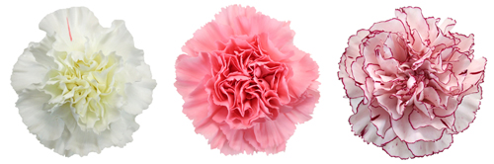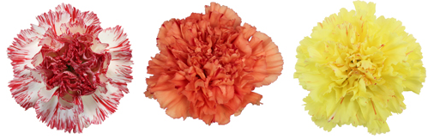

10:00 A.M. UNTIL 3.00 P.M. MAY 13, 2018

Breakfast

Scrambled Eggs Hash Browns
French Toast Bacon
Sausage Links Omelets to order

Entrees

Chicken Tetrazzini Honey Baked Ham
Sausage & Peppers Turkey & Gravy
Green Beans Almandine Whipped Potatoes

ALL SOFT DRINKS ARE INCLUDED

The Best Sweet Table In Town!

Homemade Pastries

Fresh Fruit Salad Bar

Adults $24.95 Children $10.95(Children 4-12)
Tax &Tip are not included

FULL MENU AND DINNER SPECIALS AFTER 3:30 UNTIL 8:00
COCKTAILS ARE AVAILABLE

